**Curriculum Vitae**

ASHFAQUE MAHMUD.

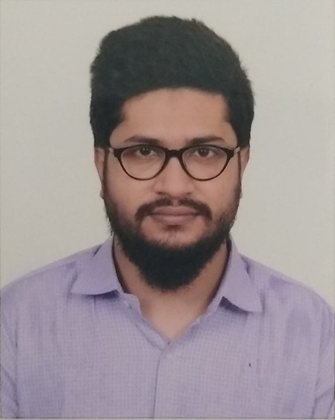

**Address:** 11/5, Free School Street, Kathalbagan, East Dhanmondi, Dhaka- 1205

**Contact No:** 01521316104, 01316022011

**E-mail:** [ashfaquemahmud3@gmail.com](mailto:ashfaquemahmud3@gmail.com)

# Career Objective

Working in a demanding job for a reputable company, where career advancement is dependent on performance. The position's key priorities are accountability and responsibility. It is the position in which education and prior experience may be used ethically to help the employer achieve its goals and contribute to the well-being of society.

# Academic Records

**Bachelor of Business Administration (BBA)**

BRAC University

Major in Human Resource management & Computer Information Management CGPA of 3.59 out of 4.00 scales

Summer 2016- Spring 2021

**Higher Secondary Certificate (HSC)** Bogura Cantonment Public School & College Board: Rajshahi

Group: Science

GPA of 5.00 out of 5.00 scales Completion year: 2015

**Secondary School Certificate (SSC)** Bogura Cantonment Public School & College Board: Rajshahi

Group: Science

GPA of 5.00 out of 5.00 scales Completion year: 2013

# Language Ability

* Bengali
* English

# Technical Ability

Good Knowledge of Windows Operating System, Microsoft Office, Microsoft Project, Web Browsing and Computer Hardware, Microsoft Power BI, Microsoft Visio, Microsoft Access, Tableau, Data Visualization.

# Work Experience

* 1. Human Resources Officer at **Mechanic Koi** (From 1st March, 2021- May 2021)

# Duties and Responsibilities

* Work with company CEO and Director to strategically plan HR initiatives that will benefit the company and encourage more efficient and beneficial work from employees.
* Direct all hiring and training procedures for new employees.
* Continually educate employees on company policies.
* Monitor employee progress and stay abreast on company climate and culture, ensuring it stays positive and productive.
* Coordinate and direct work activities for managers and employees.
* Foster cross-functional relationships and ensure managers and employees are properly connected.
* Regularly meet with employees for progress reviews and assessments, discussing any problems or grievances they may have.
* Promote a positive and open work environment where employees feel comfortable speaking up about issues.
* Manage and supervise other HR staff, ensuring they are assigned and carry out proper tasks.
  1. HR & Admin Intern at **Mettro Express** (From 1st December, 2020 to 28th February, 2021)

# Duties and Responsibilities

* + - Assist the recruitment and selection process.
    - Job advertisements posting, screening CVs, conducting telephone screenings.
    - Coordinate interview teams, participate in interviewing candidates and ensure that documentation is collected and recorded/tiled.
    - Evaluate the need for employee training and development and make recommendations.
    - Ensure Smooth running of all administrative functions in corporate office &warehouse.
    - Investigate employee relations issues.

# Personal Information

**Father’s Name :** K.M. Masud Hasan **Mother’s Name :** Momotaz Begum **Date of Birth :** 03 December 1997

**Nationality :** Bangladeshi

**Gender :** Male

**Marital status :** Single

**Religion :** Islam

**Permanent Address :** “MALIHA” West side of ladies club, Jaleshwaritala, Bogura.

# Reference

Ms. Mayesha Tasnim

Lecturer, Department of Business Studies (HRM) BRAC University, Dhaka.

Contact No. 01822002221

Email: [mayesha.tasnim@bracu.ac.bd](mailto:mayesha.tasnim@bracu.ac.bd)

# Declaration

I, the undersigned, solemnly declare that all the information furnished in this resume is free of errors to the best of my knowledge.

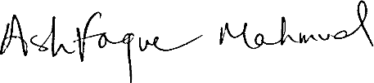

………………………………………..

Ashafaque Mahmud